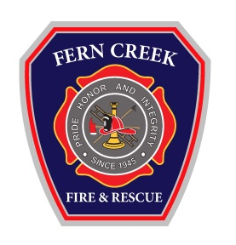
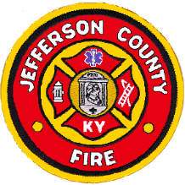
Fern Creek Fire Protection District
6200 Bardstown Road – P.O. Box 91025
Louisville, Kentucky 40291
(502) 239-7075
Fax (502)-239-1872
www.ferncreekfire.com

Fern Creek Fire & EMS is currently accepting applications for full-time firefighters. Applications are available by request beginning July 14, 2020 and ending July 28, 2020. To receive and submit an application you can visit our website, contact sevans@ferncreekfire.com or one can be obtained in person at the address listed below.

Fern Creek Fire & EMS Station 1
6200 Bardstown Rd.
Louisville, KY 40291

Pay/Benefits: Estimated Yearly Wage Range

$34,784.80- $39,115.10/yearly

(Wages based on Certifications and Licensure and contingent upon successful completion of hiring process)

Additional pay benefits include:

- $4,000.00 state incentive (annual 100hr training requirement), for 400 hour Kentucky Fire Commission certified Firefighter.
- Average hour work 56/week Based on a 24/48 work schedule
- Employer paid health, dental and vision insurance for employee
- Participation in Kentucky County Employee Retirement System (hazardous)
- Paid Time off and sick leave based on accrual
- Select Paid holidays
- Employer paid Life Insurance policy for member

Minimum Qualifications
- Minimum of 18 years of age
- Minimum of a high school diploma or GED
- Valid driver’s license
- Auto Liability Insurance, current
- Satisfactory criminal and employment background check
- Successful completion of a Fern Creek Fire provided physical examination
- Kentucky certified Emergency Medical Technician (Preferred) (must be certified within 1 year of service)
- Minimum of 150 hour State Fire Fighter 1 Certification (must complete 400 hr. certification within 1 year of employment)
- A CPAT card as certified by the Kentucky Fire Commission at date of hire. The CPAT requirement may be waived for a lateral transfer who is currently employed with or who has previously been employed by a Kentucky fire department prior to January 1, 2013 in accordance with KRS Chapters 67, 75, and 95; and who has not been out of the fire service for more than one (1) year

The Fern Creek Fire Protection District does not discriminate in employment on the basis of race, color, religion, sex (including pregnancy and gender identity), national origin, political affiliation, sexual orientation, marital status, disability, genetic information, age, membership in an employee organization, retaliation, parental status, military service, or any other factor.

